**Question 1**

1. If x(n) is a discrete-time signal, then the value of x(n) at non integer value of ‘n’ is?  
   a) Zero  
   b) Positive  
   c) Negative  
   d) Not defined
2. 3. The phase function of a discrete time signal x(n)=an, where a=r.ejθ is?  
   a) tan(nθ)  
   b) nθ  
   c) tan-1(nθ)  
   d) none of the mentioned
3. 5. x(n)*δ(n-k)=?  
   a) x(n)  
   b) x(k)  
   c) x(k)*δ(n-k)  
   d) x(k)*δ(k)
4. 1. The system described by the equation y(n)=ay(n-1)+b x(n) is a recursive system.  
   a) True  
   b) False
5. 1. If x(n) is a discrete-time signal, then the value of x(n) at non integer value of ‘n’ is?  
   a) Zero  
   b) Positive  
   c) Negative  
   d) Not defined
6. 7. The odd part of a signal x(t) is?  
   a) x(t)+x(-t)  
   b) x(t)-x(-t)  
   c) (1/2)*(x(t)+x(-t))  
   d) (1/2)*(x(t)-x(-t))
7. 2. Zero-state response is also known as ____________  
   a) Free response  
   b) Forced response  
   c) Natural response  
   d) None of the mentioned
8. 9. The total solution of the difference equation is given as _______________  
   a) yp(n)-yh(n)  
   b) yp(n)+yh(n)  
   c) yh(n)-yp(n)  
   d) None of the mentioned
9. 1. Which of the following is done to convert a continuous time signal into discrete time signal?  
   a) Modulating  
   b) Sampling  
   c) Differentiating  
   d) Integrating
10. 6. Let x1(t) and x2(t) be periodic signals with fundamental periods T1 and T2 respectively. Which of the following must be a rational number for x(t)=x1(t)+x2(t) to be periodic?  
    a) T1+T2  
    b) T1-T2  
    c) T1/T2  
    d) T1*T2

**Question 02**

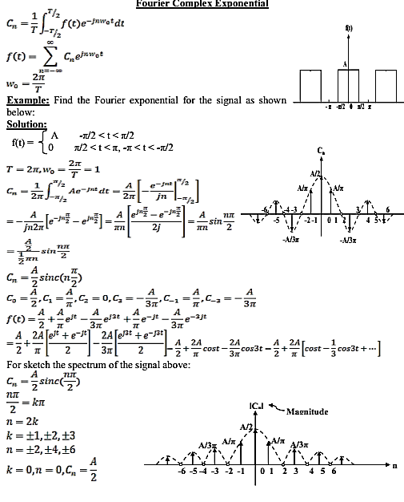

**Question 03**

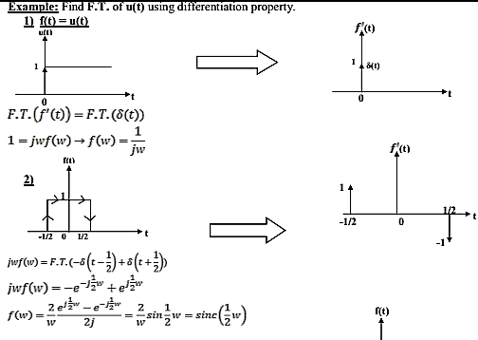

**Question 4**

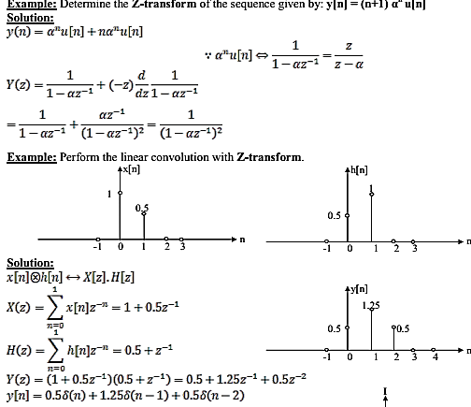

**Question 05**

